**How spring find application.properties?**

It is basically src/main/file by default and if we keep it anywhere, we need specify the path then.

Every .class, jar file and dependencies are packages in ClassPath.

We can write configuration in YAML format instead of key-value.





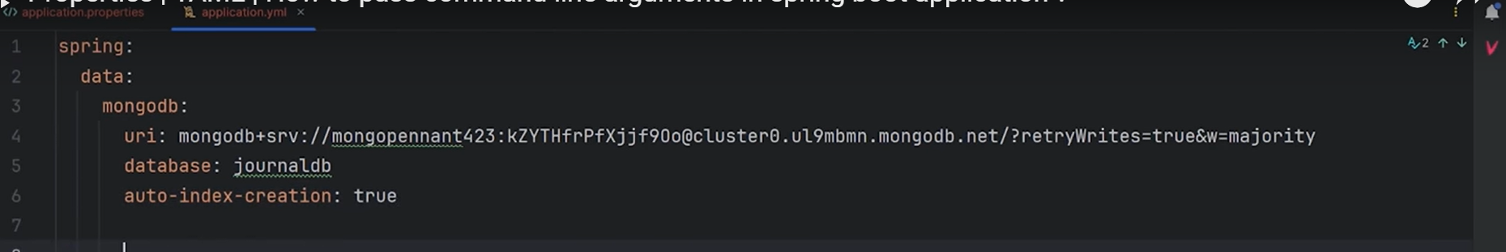

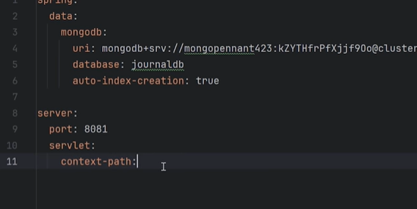

Priority is given to properties file instead of YAML

You can give properties via command line as well.



